Dhana Laxmi Sirigireddy | Design of ESP32 + VL53L8CX BLE sensor system

Assignment
Design a small ESP32 + ToF BLE sensor tag where:
System
- MCU: ESP32 (ESP32-C3 or ESP32-S3 module)
- Sensor: VL53L8CX ToF over I2C (LPn + INT connected to GPIO)
- Power: 1-cell LiPo + BQ-series charger with power-path
- Comms: BLE (stream when connected, buffer when not)
Hardware task (PCB in KiCad/Altium)
- LiPo JST + USB input for charging
- BQ charger configured (charge current/termination) + documented USB vs battery behavior
- 3.3V rail sized for ESP32 peaks, proper decoupling
- ToF I2C integration (pullups/level shifting if needed), clean routing
- Bring-up features: test points (VBAT/VSYS/3V3/GND + charger status), programming header, clear silkscreen
Firmware task (ESP-IDF + FreeRTOS)
- Fixed-rate sampling (e.g., 20 Hz) independent of BLE
- Ring buffer stores last N seconds; track drops/overflows
- BLE GATT service:
  - Notify “Data” characteristic
  - Write “Control” characteristic (start/stop, set rate, clear buffer)
- When BLE connects: stream latest (or buffered) data without blocking sampling
- When sampling stops: put ToF in low power via LPn (optional light sleep)
Deliverables
- PCB project + 1–2 page design note
- ESP-IDF project + README (build/flash + UUIDs + how to test in nRF Connect)
I started by picking the microcontroller for our project and went with the ESP32-C3 WROOM-02.
The C3 is a single-core chip which is great for low-power stuff and simple WiFi/BLE tasks. It runs a bit slower than the ESP32-S3, which actually helps save energy for lightweight applications like ours.
The S3, on the other hand, is dual-core and more powerful, designed for heavier workloads like AI or advanced data processing.
Since our project is mostly about basic wireless communication and keeping power consumption low, the C3 is the better fit.
I didn’t go with the C3 Mini because the WROOM-02 gives us more flash memory and easier integration for the board we’re building.
Component Selection
ESP32-C3-WROOM-02-N4 Espressif Systems - RF Receivers, Transceivers - Distributors, Price Comparison, and Datasheets | Octopart component search (from Component Search Engine )
Datasheet
https://www.mouser.in/datasheet/2/891/Espressif_Systems_04082021_ESP32_C3_WROOM_02-2295851.pdf
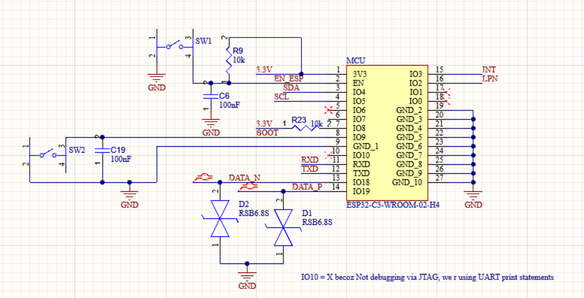
Next,
Sensor
I initially considered using an off-the-shelf breakout board to make things easier, but I decided to design the whole circuit myself. It turned out to be simpler given the power management path I wanted to implement.
Useful sources
BREAK OUT BOARD SCHEMATIC LINK POLOLU
Datasheet
https://www.st.com/resource/en/datasheet/vl53l8cx.pdf
The power-up sequence is detailed on page 11 of the datasheet.
The sensor is connected to ESP via I2C protocol.
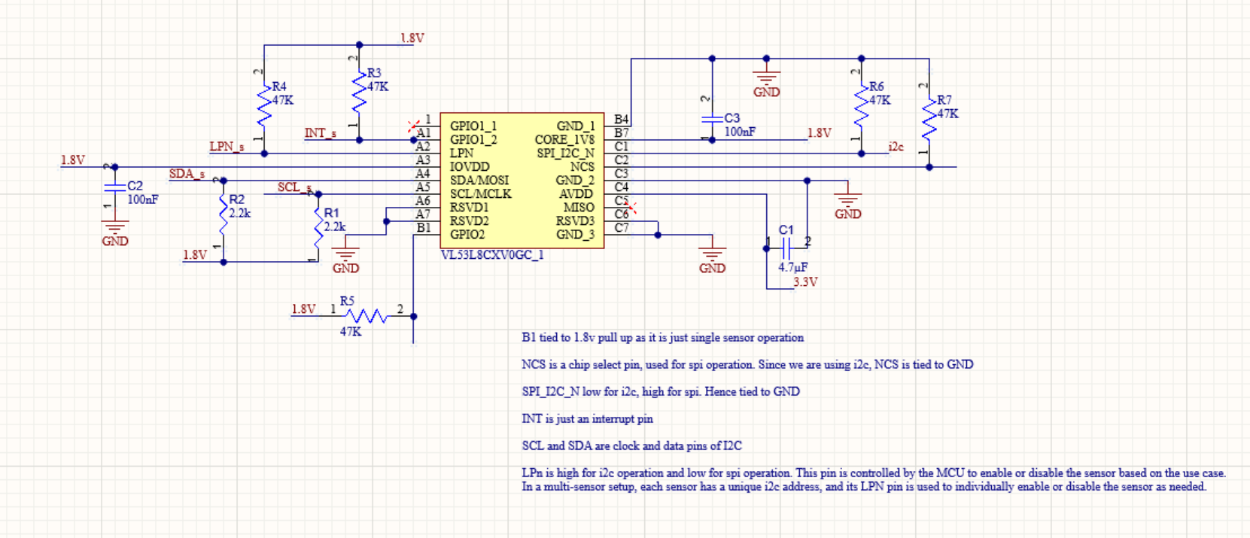
To communicate with the ESP, I needed a level shifter because the ESP’s GPIOs are 3.3 V while the sensor pins are 1.8 V. I chose the TXS0108ERGYR for this purpose.
I followed the typical application circuit on page 19 of the datasheet.
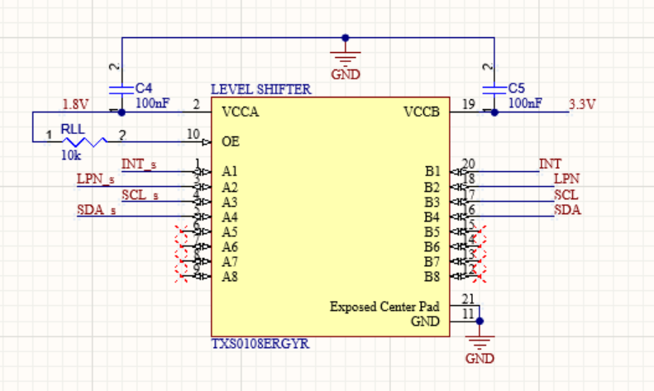

Flashing and Debugging the ESP32-C3 Board
IO9 is the boot pin on this module.
The ESP32-C3 WROOM-02 has a built-in USB peripheral, which theoretically allows flashing via USB directly by connecting the USB-C data lines to IO18 (D+) and IO19 (D−).

However, this method is not as straightforward as using a standard USB-to-UART bridge.
To make development simple, I implemented a USB-to-UART bridge using the CP2102. This setup:
- Automatically handles boot/reset toggling
- Provides USB debugging, allowing UART print statements to be read directly via USB-C
- Works with standard tools like esptool.py for firmware flashing
For minimal hardware, the board can be flashed manually using the exposed UART pins (TXD, RXD, VCC, GND) along with the BOOT and EN buttons:
- Hold BOOT (IO9) LOW
- Press and release EN (RESET)
- Release BOOT
- Run
I haven’t used the JTAG feature; those pins are repurposed for I2C, and anyway UART debugging covers all necessary testing and log output.
According to the official ESP-IDF documentation, ESP32 boards typically use a USB-to-UART bridge to expose a virtual COM port for flashing. If auto-download isn’t available, holding BOOT while resetting the board manually enters flash mode. This matches my setup: the CP2102 bridge handles auto-boot, enables convenient UART debugging, and supports standard flashing tools, making development and testing much easier. (ESP-IDF Docs)
Schematic source help - https://dl.espressif.com/dl/schematics/SCH_ESP32-C3-DEVKITC-02_V1_1_20210126A.pdf

Powerpath

The board is powered using either a LiPo battery connected via a JST connector or USB-C.

The BQ24072 battery charger IC manages power flow between these sources and the system. (BQ24072 Datasheet). Page 29 has a useful application schematic.
VBUS (USB-C input) When USB-C is connected, it provides power to the BQ24072, which charges the LiPo battery and supplies the system.
VBAT (Battery) Represents the LiPo battery voltage. The battery powers the system whenever USB-C is disconnected or the charger allows.
VSYS (System output from BQ24072) The charger IC outputs VSYS, which automatically selects the higher-priority power source (USB or battery) to provide a stable system voltage.
LDO → 3.3 V rail VSYS is fed into a low-dropout regulator (LDO) to generate a clean 3.3 V supply for the ESP32-C3 and peripherals.
Differential pair impedance
1. Change the rules in diff routine
2. Create impedance profile in layer stack manager
3. Apply in rules
—--

